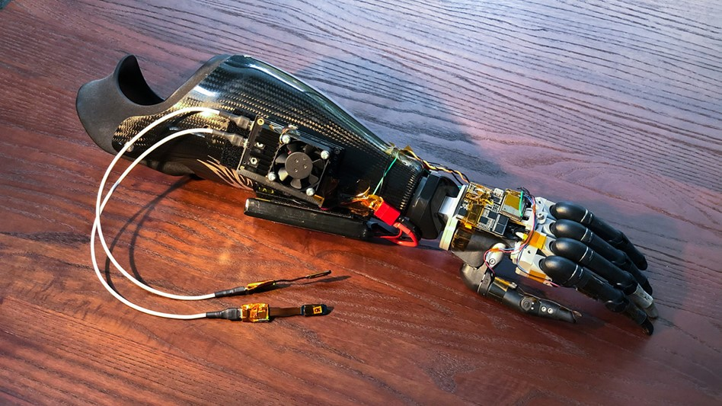

Project Extension
Special Topic – Semester One 2026
Otago Polytechnic.

Written by
Connell Webb

2026

Introduction
Project Extension was the name given to my special topic for semester one of 2026 and aimed at determining whether it is possible to create a low-cost, repairable robotic prosthetic arm. This was chosen because I saw that there was an increasing demand for these prosthetics in the healthcare sector, and my joint interest in both health and robotics made this a very interesting prospect.

Goal Outlines.
- Create a robotic arm that can bend and grip objects via user input: The main goal of the project was to create the arm. I wanted to produce a product that would bend and straighten given input from muscles, and then using nerves that were under the skin of the elbow joint, have the user be able to grip and loosen their grip of the robotic hand.
- Create a basic platform for future student work in robotics: Robotics is something that I very much enjoy and would love for others to be able to do so as well, because of this Vaughn and I thought a fantastic goal of this project would be to pave the way for future students, to be able to continue on with this project, and ones like it in the future.
- Utilize parts that are readily available: One of the main barriers that exists for the accessibility of devices like this is that parts are either expensive, or brought in from overseas, so the main constraint became simple although just as important, if not more so than the rest. All parts where possible must be bought from local shops.
- Keep the costs low: These arms are a solved problem with many high tech and non-robotic ones all existing in a spectrum of usability and price, however the low-end robotic arm point of that spectrum I feel is largely unexplored. This is the crux of the issue here. An average robotic prosthetic arm can cost in the range of NZD$10,000 - NZD$50,000 with higher range models going as high as NZD$100,000. I wanted to see if we were able to create one for a fraction of the cost.

Research

Verification

Implimentation

